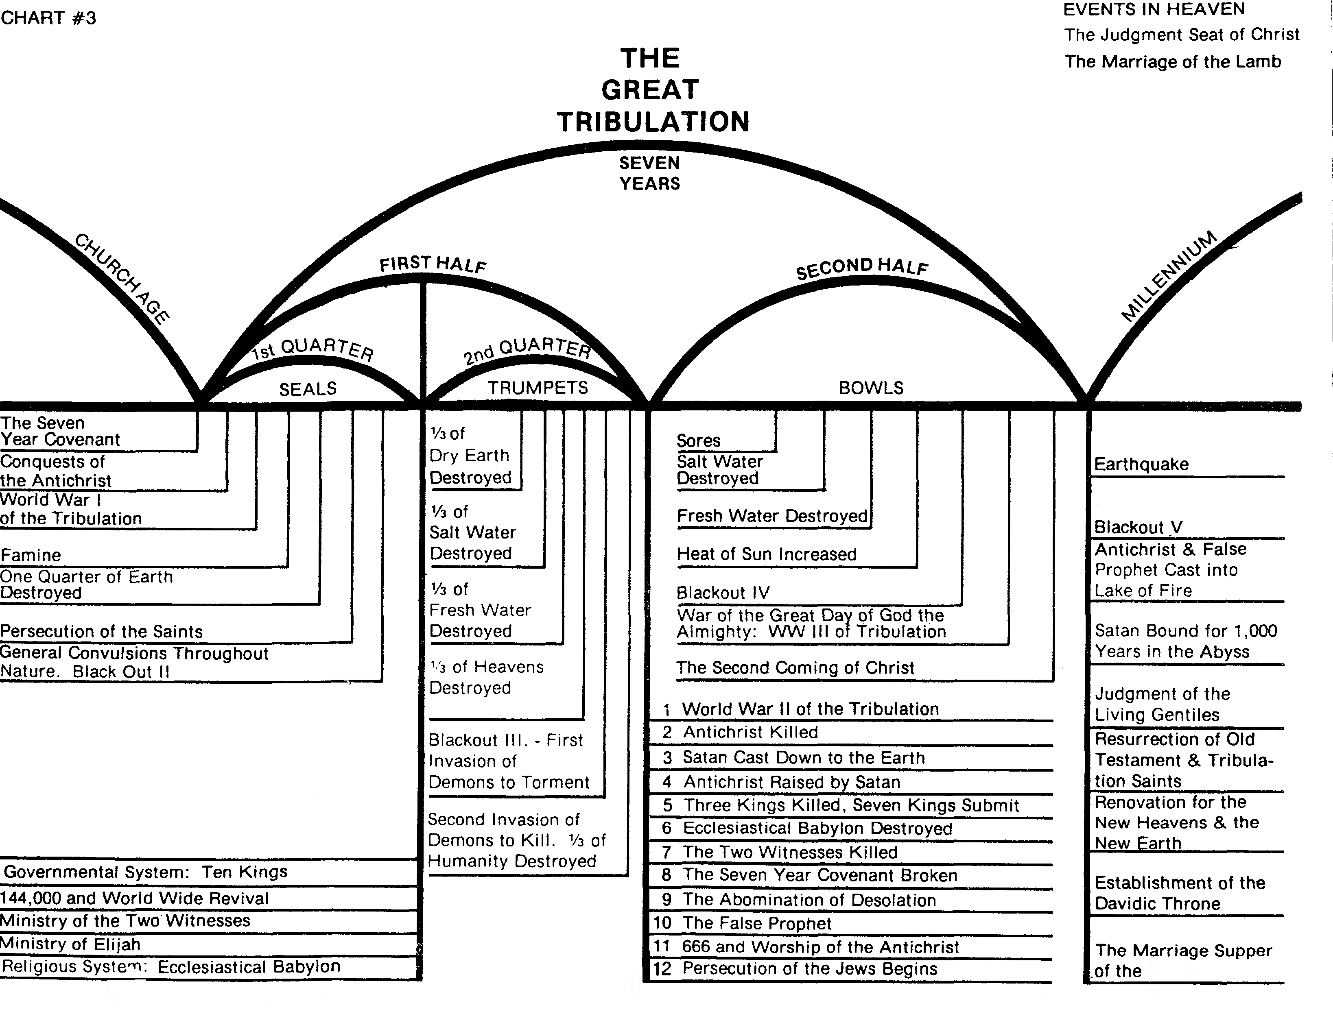
The Marriage Supper of the Lamb
Ariel Ministries
Dr. Arnold G. Fruchtenbaum

